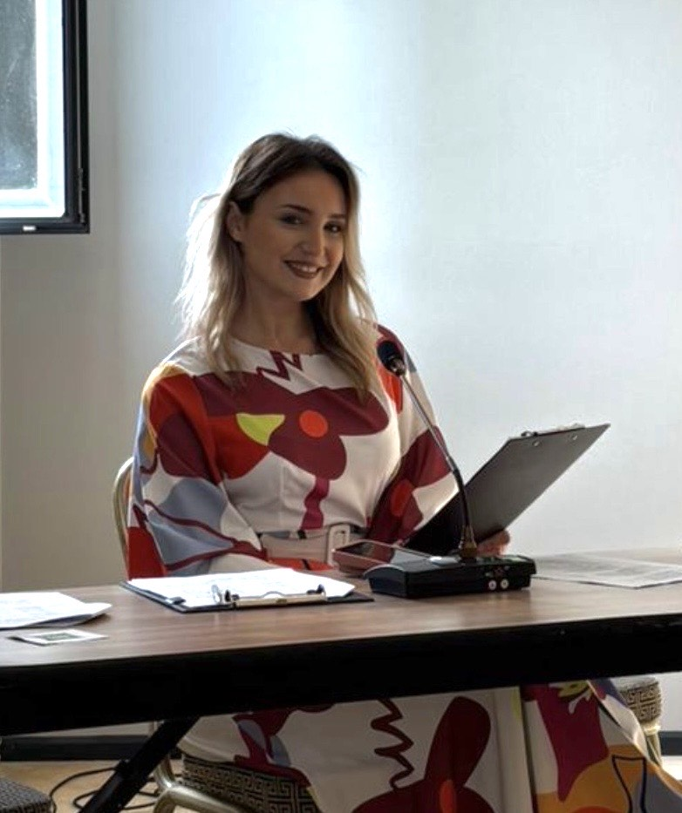
My name is Emman Muhović, and I am a third-year student at the University of Sarajevo – Faculty of Educational Sciences (Department of Elementary School Education).
I participated in the EUPeace Winter School in Marburg, and after that in the EUPeace Post-Summer School in Sarajevo. Both of these programs were part of EUPeace Work Package 3, which focuses on education, learning, and student mobility. Through EUPeace, I had the opportunity to expand my academic knowledge beyond my home university and to experience learning in an international and interdisciplinary environment. The lectures and workshops were very educational, well-structured, and interactive, encouraging active participation, discussion, and critical thinking. This approach helped me better understand complex topics and connect theory with practical examples.
These experiences were closely connected to my studies and helped me understand how my academic field functions in different educational systems. I was introduced to new teaching methods and academic perspectives, which motivated me to become a more independent and engaged student. Being in Marburg was especially meaningful because it allowed me to experience a different academic and cultural environment. Later, during the Post-Summer School in Sarajevo, I had the chance to reflect on what I learned in Marburg and apply it, and I also learned a lot of new things. It was both a continuation of my international experience and an opportunity to gain additional knowledge and skills in a local context. Education is extremely important for my future profession, not only because of the knowledge it provides, but also because of the values it promotes. Through EUPeace, I strengthened my intercultural competence, learned how to work effectively with people from different cultural backgrounds, and became more open to diverse perspectives.
Overall, the EUPeace project played an important role in shaping me both academically and personally.

